**MDF Rose Engine Lathe 2.0**

**with Stepper Motor Drive**



**Instructions for Building**

**Jigs, Fixtures, & Add-Ons**

**Version 1.5**

**30 October 2022**

This document is intended to help one familiar with the MDF rose engine to easily build the identified jigs, fixtures, and add-ons. You can purchase these from us at [www.ColvinTools.com](http://www.ColvinTools.com), or build them yourself.

As you get started with building these jigs, fixtures, or add-ons to the MDF rose engine lathe, please consider making the machine exactly according to the outlined instructions. There are lots of ways you can modify this, and, quite frankly, the MDF rose engine encourages experimentation. But it is best to attempt those modifications after understanding how it works. Some ideas which sound grand may not appear so after understanding how the machine works (we speak from experience).

If you have any questions on the terminology in this document, check out the “Ornamental Turning Book of Knowledge” ([www.OTBoK.info](https://www.otbok.info/)).

Throughout this document, I’ve tried to show the MDF in its native color of tan/brown. There are differences in the images I captured from the CAD drawing made, but those are not representative of the machine’s differences.

The added pieces are typically shown in different colors to ensure they stand out from the MDF rose engine lathe.

Unless otherwise noted, the MDF is ¾” thick.

If you have any questions, please contact us at [ColvinTools@Gmail.com](mailto:ColvinTools@Gmail.com).

Good luck and we hope you enjoy this machine as much as we.

Rich Colvin & Jack Zimmel

Permission is not granted to manufacture these for sale.

Table of Contents

Amplitude Adjuster 4

Bill of Materials 6

AA1 – MDF Spacer Block 8

AA2 – MDF AA Alignment Block 9

AA3 – Horizontal Bar 10

AA4 – Vertical Bar 10

105 – AA Lever Arm Axle 11

R1 – AA Rubber 12

Assembly 14

Using the AA 16

Amplitude Adjuster Components for Independent Amplitude Adjustment 18

Backstop 19

Clamp 20

Rosette Phaser / Multiplier 21

Bottom Piece 23

Top Piece 23

Side Pieces 24

Pumping Mechanism 26

Bill of Materials 28

Spindle Parts 30

Frame Parts 31

Assembly 36

Installing and Aligning 39

Curvilinear Slide 42

Bill of Materials 43

Instructions 46

# Amplitude Adjuster

The amplitude adjuster for the MDF Rose Engine Lathe 2.0 is shown installed to the right.

Also shown are some extra rubbers. Note that the RS1 has been flipped 180° to open up more space.

Details for building this follow the bill of materials.



This diagram shows the AA removed from the MDF Rose Engine Lathe 2.0.

## Bill of Materials

Parts required for building this are below.

| Item # | Item | Qty | Source | Source  Part Number | Comments |
| --- | --- | --- | --- | --- | --- |
|  | **MDF Parts** |  |  |  |  |
| AA1 | MDF Spacer Block | 1 |  |  |  |
| AA2 | MDF AA Alignment Block | 1 |  |  |  |
|  | **Machined Parts** |  |  |  |  |
| AA3 | Aluminum bar, ¼” x 1” | 1 |  |  | A piece 7 ¾” to 8” long is needed.  Used for the horizontal bar. |
| AA4 | Aluminum bar, ¼” x ¾” | 2 |  |  | Two pieces, 12 ½” to 13” long (each) are needed.  Used for the vertical bars. |
| R1 | Rubber, Pointed | 2 |  |  |  |
| R2 | Rubber, 2” Radius | 2 |  |  |  |
| R3 | Rubber, Flat | 2 |  |  |  |
|  | **Other Parts** |  |  |  |  |
| 101 | Carriage Bolts, ¼”-20, 4” long | 2 | McMaster-Carr | 93548A560 |  |
| 102 | Washer, ¼” | 8 | McMaster-Carr | 90107A029 |  |
| 103 | Lock Washer, ¼” | 1 | McMaster-Carr | 92146A029 |  |
| 104 | Nut, ¼”-20 | 5 | McMaster-Carr | 95505A601 |  |
| 105 | Bolt, ¼”-20 | 1 | McMaster-Carr | 90272A196 | Used as the axle for the vertical bars (AA4). Cut down per drawing on pg. 11). Need 1 ½” of unthreaded area. |
| 106 | Spacer, ¼” ID, ½” Long | 1 | McMaster-Carr | 92510A765 |  |
| 107 | Collar, ¼” ID | 1 | McMaster-Carr | 6432K12 |  |
| 108 | T-Track Bolt, ¼”-20, 2 ½” to 3” Long | 2 | McMaster-Carr |  |  |
| 109 | T-Track Nut, ¼”-20 | 2 | McMaster-Carr |  |  |
| 110 | Bolt, #8-32, 5/8” Long | 2 | McMaster-Carr | 90272A196 |  |
| 111 | Knurled Nut, #8-32 | 2 | McMaster-Carr | 92741A120 |  |

## AA1 – MDF Spacer Block

This spacer block is used to attach the AA to the headstock at the correct distance. You will need to drill two holes in H4L on the headstock to match the thru holes.



5 ¼”

2 7/8 ”

**Top View**



1 ½”

1 ½”

Holes drilled for ¼” bolts.

“G” bit recommended.

**Side View**

## AA2 – MDF AA Alignment Block

This is used to help keep the vertical bars aligned to the rosettes.



2 ”

3/8 ”

3/8 ”

3/8 ”

1/2 ”

3/4 ”

3/4 ”

5 3/4 ”

2 1/4 ”

1 3/8 ”

**Top View**



Holes drilled for ¼” bolts.

“G” bit recommended.

Center in slot for T-Track.

**Side View**

**NOTE:** There is also a 3D printable version in the 3D Printed Parts manual in the MDF Rose Engine Lathe 2.0 Library (<https://mdfre2.ColvinTools.com>).

## AA3 – Horizontal Bar

The horizontal bar is made from 1” x ¼” aluminum bar.



Hole drilled for ¼” bolt.

“G” bit recommended.

½”

½”

4”

7 ¾”

## AA4 – Vertical Bar

The vertical bars are made from ¾” x ¼” aluminum bar. There are two of these.



½”

8”

Hole drilled for ¼” bolt.

“G” bit recommended.

Hole drilled for #8-32 bolt.

#18 bit recommended.

12 ½” to 13”

## 105 – AA Lever Arm Axle

This is made from a partially threaded bolt. It can be cut with a hack saw, but be sure to smooth off the end, and chamfer it.

The one specified has sufficient unthreaded space.



~1 ½”

End is smoothed and chamfered after cutting.

## Square Description automatically generated with medium confidenceR1 – AA Rubber

Two are needed at any one time. More can be made. The basic shape to start with is like shown to the right, with measurements below.



½”

¼”

¾”



2 3/8”

2 3/8”

Through hole drilled for #8-32 bolt. #18 bit recommended.

1 3/16”

3/8”

Partial hole drilled for head of #8-32 bolt. Needs to be > 0.350”. 3/8” Forstner bit recommended. Drill this first. The point marks where to drill the through hole. Depth of the partial hole is 0.100” to 1/8”.

**Flat Rubber**



**Pointed Rubber**

### Various Rubber Shapes

Some examples of rubber shapes are below. Others can be made to accomplish the desired results.



|  |  |  |
| --- | --- | --- |
| **Pointed** | **Flat** | **Rounded**  **(2” Radius)** |

## Assembly

1. Drill the two holes needed in the headstock.
2. Attach the MDF Spacer Block (AA1) to the headstock using two carriage bolts with nuts and flat washers (#101, #102, & #104). The spacer block should be flush with the top of H4L.

**Looking from the back**

(H2 removed)



Nut

Flat Washer

MDF Spacer Block

Carriage Bolt

H4L

1. Attach the Axle (#105, cut as shown on pg. 11) to the Horizontal Bar (AA3) using two nuts (#104) and a lock washer (#103).
2. Add a flat washer (#102), one vertical arm (AA4), the spacer (#106), the 2nd vertical arm (AA4), and the collar (#107).



Lock Washer

Washer

Horizontal Bar

Vertical Bars

Nuts

Spacer

Collar

**Looking from the front**

## A picture containing text Description automatically generatedUsing the AA

1. Attach a rubber to each Vertical bar using an #8-32 bolt (#110) and a knurled nut (#111).
2. Attach the Horizontal bar to the MDF Spacer Block using two nuts and flat washers (#102 & #104). Ensure the vertical bars so that they are aligned with the front column (B3) on the MDF Rose Engine Lathe 2.0.
3. Add the MDF AA Alignment block (AA2) and hold it in place using two T-Track bolts (#108) and nuts (#109).



MDF AA Alignment Block

Front B3 Column

Vertical Bars

AA Rubbers

**Looking from the top**

MDF Alignment Block installed at the top of the front B3 column.

* If reducing amplification, install it at the top of B3.
* If increasing amplification, install it below the RS1 rubber support, but as high as possible so as not to interfere with the AA rubbers.

# Amplitude Adjuster Components for Independent Amplitude Adjustment

****These components can be used with the amplitude adjuster specified above. They are shown below and are installed on the MDF Rose Engine Lathe 2.0 in the picture to the left.

## Backstop

This is made from 3 pieces of ¾” MDF.



Holes drilled for ¼” bolt.

“G” bit recommended.

15”

12”

3”

1 ½”

5”

## Clamp

The clamp consists of two pieces of aluminum and two screws. Two clamps are needed.



> 1 ¼”

¾”

0.240”

0.240”



3/8”

1/8”

1/8”

Two Separate Pieces

The two screws are #8-32.

The thru holes on the L-shaped piece (the top one in the picture at the top right) are drilled #16 (0.177”). The screws simply feed thru these.

The thru holes on the flat piece (the bottom one in the picture at the top right) are drilled #28 or #29. These are tapped for a #8-32 screw.

# Rosette Phaser / Multiplier

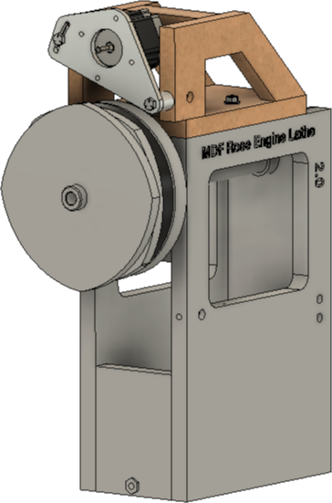This device is used to allow a second stepper motor to drive the rosette, separately from the stepper motor driving the spindle.

It is facilitated by the Multiple Stepper Motor Control System, version 3.0. The upper stepper motor is driven as the M3 axis.

This device uses a second copy of the same components as the spindle stepper motor drive:

* Motor bracket
* Motor bracket pacers (2)
* Motor bracket screws, washers, and nuts (2 sets)
* Stepper Motor Drive gear
* Spindle Drive gear
* Drive belt

Also needed is a Needle Roller Bearing (McMaster-Carr p/n 5909K36) to separate the two drive gears.

When using it with the **Amplitude Adjuster for Independent Amplitude Adjustment** outlined on 18, the arms will need to be spaced out an additional 0.85”:

* MDF Spacer Block will need to be 0.85” wider, and



2 7/8” + 0.85”

* MDF AA Alignment Block will need to be 0.85” further away from the vertical T-Tracks to which it attaches.



1/2” +

0.85”

This is to accommodate the second drive gear, and the needle roller bearing, and aligning the rubbers with the new position for the rosettes.

## Bottom Piece

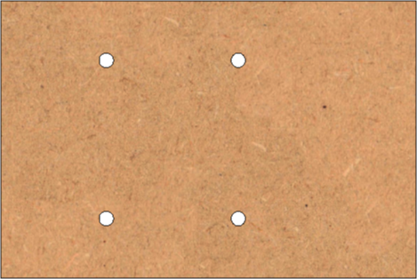

1 1/8”

1 1/8”

5 1/4”

7 7/8”

2 1/2”

2”

This is made from ¾” MDF. One is needed.

The 4 holes are ¼” in diameter. These accommodate the screws which hold this device to the top of the headstock (via the T-Tracks).

## Top Piece

This is made from ¾” MDF. One is needed.

3 3/4”

1 1/2”



## Side Pieces



Drill ¼” diameter,

2” deep

8 3/4”

2”

2”

7/8”

4 5/8”

1 1/2”

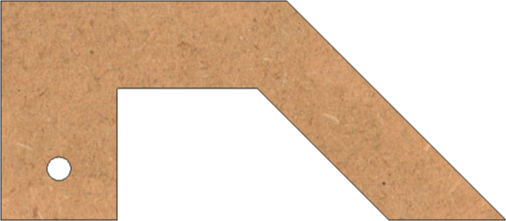

1”

Drill 13/32” diameter,

Through

This is made from ¾” MDF. Two are needed.

On the front piece, drill holes as shown.

Do not drill into the back one yet piece yet; drill those after aligning the stepper motor bracket.

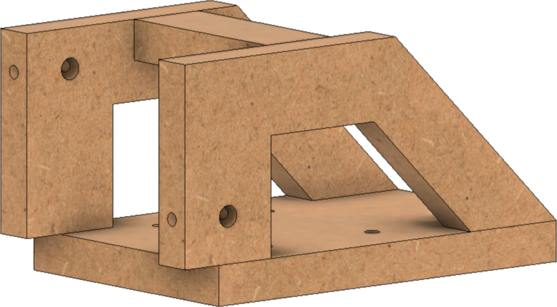Once assembled, the MDF pieces will look like this.

# Pumping Mechanism

The pumping mechanism for the MDF Rose Engine Lathe 2.0 is shown in the picture to the right, and as attached to the headstock in the picture below.

It was designed to attach to the back of the headstock, using the T-Tracks there. This is to facilitate also using the Rosette Phaser/Multiplier at the same time.



Additionally, testing has shown that this configuration also allows for rocking whilst pumping, creating a whole host of opportunities for the artist using this machine.

The picture to the right shows it attached with the other parts of the MDF Rose Engine Lathe 2.0 also in the picture. This is to show how it clears the rear rubber column.

Details for building and assembling this follow the bill of materials.

For the rubbers to use on this attachment, they are 3D printed (they are shown in blue in this picture). The directions for those are in the MDF Rose Engine Lathe 2.0 Library (<https://mdfre2.colvintools.com>). The book is the black one on the 2nd shelf. It is titled, “3D Printed Parts”.

These rubbers have a curved rubbing edge so that they do not gouge into the rosette(s). Two examples are below:

|  |  |
| --- | --- |
|  |  |
| **Point Rubber** | **Round Rubber** |

## Bill of Materials

Parts required for building this are below.

| Item # | Item | Qty | Source | Source  Part Number | Comments |
| --- | --- | --- | --- | --- | --- |
|  | **Spindle Parts** |  |  |  |  |
| 101 | Clamping, 2-Piece Shaft Collar, 1” diam. | 1 | McMaster-Carr | 6436K18 |  |
| 102 | Spring, Compression  3" Long, 1.029" ID | 1 | McMaster-Carr | 9657K444 |  |
| 103 | Bearing, Needle Roller  for 1” shaft diam. | 1 | McMaster-Carr | 5909K36 |  |
| 104 | Washer for Needle Bearing  for 1” shaft diam. | 1 | McMaster-Carr | 5909K49 |  |
| 105 | Thrust Bearing  for 1” shaft diam. | 2 | McMaster-Carr | 5906K523 | Bronze, oil-embedded. For 1" Shaft dia, 1/8" Thick |
|  | **Purchased Parts** |  |  |  |  |
| 201 | Hex Head Bolt, ¼”-20,  ¾” Long | 4 | McMaster-Carr | 91268A502 |  |
| 202 | Hex Head Bolt, ¼”-20,  2 ¼” Long | 4 | McMaster-Carr | 92865A551 |  |
| 203 | Nut, ¼”-20 | 8 | McMaster-Carr | 95505A601 |  |
| 204 | Washer, ¼” | 18 | McMaster-Carr | 90850A100 |  |
| 205 | Wing Nut, ¼”-20 | 4 | McMaster-Carr | 90866A029 |  |
| 206 | Set Screw Shaft Collar  ½” ID | 2 | McMaster-Carr | 6432K16 |  |
| 207 | Ball Stud | 1 | McMaster-Carr | 9512K51 |  |
| 208 | Coupling Nut, ¼”-20 | 1 | McMaster-Carr | 90264A435 |  |
| 209 | Carriage Bolt, ¼”-20  4” Long | 1 | McMaster-Carr | 90185A415 |  |
| 210 | Threaded Rod, #8-32,  2-1/2" Long | 2 | McMaster-Carr | 95412A882 |  |
| 211 | Nut, #8-32 | 4 | McMaster-Carr | 90480A009 |  |
| 212 | Washer, #8 | 4 | McMaster-Carr | 92141A009 |  |
| 213 | Thumb Screw, ¼”-20  1” Thread Length | 2 | McMaster-Carr | 91882A429 |  |
| 214 | Flat Head Screw, ¼”-20  1” long | 4 | McMaster-Carr | 91253A542 |  |
|  | **Aluminum Plate and Rods** |  |  |  |  |
| 301 | Aluminum plate, ¼” Thick  6 ¼” x 3 ¼” | 1 |  |  | Base |
| 302 | Aluminum plate, ½” Thick  5 ¼” x 7 ½” | 1 |  |  | Lever Arm |
| 303 | Aluminum rod, rectangular  1” x ½”, 40” Long | 1 |  |  | Arms |
| 304 | Aluminum rod, round  ½” dia. x 5 ¼” Long | 1 |  |  | Pivot for Lever Arm |
| 305 | HDPE rod, round  1 ½” dia. X 2 ¼” Long | 1 |  |  | Spindle coupler  Similar material could be used |
|  | **Rubbers** |  |  |  |  |
|  | Rubbers | 2 | MDF Rose Engine 2.0 Library |  |  |

## Spindle Parts

### Assembly of the Spindle Parts



Needle

Bearing

#103

Washer

#104

Thrust

Bearing

#105

Compression Spring, #102

Shaft Collar

#101

Spindle

**View from the Near Side of the Headstock**

(H1 & H2 removed)

Thrust

Bearing

#105

H3

H3

## Frame Parts

### Base Plate

The base plate is made from ¼” aluminum (#301). 1 is required.

6 ¼”



½”

Drill 17/64”

(typ)

Drill 17/64”

Countersink so that

#214 is flush (typ)

3 ¼”

¾”

½”

1 ¾”

¼”

¼”

1 5/8”

3”

### Horizontal Arm #1

The horizontal arms are made from 1” x ½” aluminum rod (#303). 2 are required.

Please ignore the color differences – some odd fluke happened when copying from Fusion 360.

1 ¼”



Drill 17/64”

(typ)

**Edge View**

¼”



**Side View**

5 ¾”

9 ¾”

½”

1”

½”

1 ¾”

¾”

### Horizontal Arm #2

The horizontal arms are made from 1” x ½” aluminum rod (#303). 2 are required.

Please ignore the color differences – some odd fluke happened when copying from Fusion 360.

**Edge View**



¼”

1 ¼”

½”

Drill 17/64”

(typ)

1”



**Side View**

7 ¼”

½”

¼”

2”

Mill 17/64”

wide

### Pivot Arm

The pivot arms is made from ½” diameter aluminum round rod (#304). 1 is required.

The piece is 5 ¼” long. Drill and tap both ends for a ¼”-20 bolt. Be sure to allow for at least ¾” of threads.

Drill 7/32”

Tap ¼”-20

(typ)



### Spindle Coupler

The spindle coupler is made from 1 ½”diameter HDPE (or similar) round rod (#305). 1 is required.

The piece is 2 ¼” long.

Ball Mill 10mm diam.,

5mm deep

(Makes a hemisphere)



**Outboard Side**

Drill 1” diam.,

1 3/8” deep



**Inboard Side**

### Lever Arm

The lever arm is made from ½”aluminum plate (#302). 1 is required. The radii of the curves are not critical. However, do be sure the pivot hole is drilled before making the curve cuts.



**Edge View**

Mill 17/64”

wide

3/8”

1 ½”

1”

½”

Drill #27

Tap #8-32



**Side View**

5 ¼”

4 ½”

Drill ½”

7 ½”

2 ¼”

1 3/8” before start of curve

5 ¼”

1”

1”



**Profile View**

## Assembly



Spindle Coupler

Horizontal Arm 2

Lever Arm

Pivot Arm

Horizontal Arm 1

Base Plate

Flat Head Screw (#214), Nut (#203), & Washer (#204)

Bolt (#201), Wing Nut (#205), & Washer (#204)

Bolt (#202), Nut (#203),

& Washer (#204)

Thumb Screw (#213)

& Washer (#204)



Flat Head Screw (#214), Nut (#203), & Washer (#204)

Bolt (#202), Nut (#203),

& Washer (#204)

Collar (#206)

Thumb Screw (#213)

& Washer (#204)

Nut #203

Coupling Nut #208

Ball Stud #207

Carriage Bolt #207



Lever Arm

Rubber

(one removed)

Threaded Rod (#210)

Nut (#211) & Washer (#212)

## Installing and Aligning

### Step 1 – Move the flange, gears, and rosettes to open up space for pumping



You need space here for the pumping action to move the spindle. I aim for around 3/16”.

### Step 2: Install and align the Pumping Mechanism



2b. Move the lever arm left or right to align the rubbers with the rosettes.

2a. Align this edge so it is parallel to the top of the headstock.



### Step 3: Tighten it up



Using these two nuts, ensure the ball stud is tightly engaged with the spindle coupler during the entire rotation of the rosette.

Move the carriage bolt in or out as necessary, but then secure it in place with both nuts.

# Curvilinear Slide

The curvilinear slide for the MDF Rose Engine Lathe 2.0 is shown in the picture to the right.

It was designed to be used with a weight to keep the template follower engaged with the template. There are 3D-printed templates we have designed, but you can make your own. They are held on a T-Track and can be ¼”’ thick. MDF works well for limited-use templates, but more resilient materials are recommended if longer use is expected.

Details for building and assembling this follow the bill of materials.

For the templates which are 3D-printed, the directions are in the MDF Rose Engine Lathe 2.0 Library (<https://mdfre2.colvintools.com>). The book is the black one on the 2nd shelf. It is titled, “3D Printed Parts”.

## Bill of Materials

Parts required for building this are below.

| Item # | Item | Qty | Source | Source  Part Number | Comments |
| --- | --- | --- | --- | --- | --- |
|  | **Wood, Plate, and Rods** |  |  |  |  |
| 101 | MDF, ¾” thick |  |  |  |  |
| 102 | 2x3 / 2x4 pine board |  |  |  |  |
| 103 | Aluminum rod, rectangular - 1” x ¼” |  |  |  |  |
| 104 | Aluminum rod, rectangular – ¾” x ½” |  |  |  |  |
| 105 | Aluminum plate, ¼” thick |  |  |  |  |
| 106 | Aluminum plate, ½” thick |  |  |  |  |
| 107 | T-Track |  |  |  |  |
|  | **Purchased Components** |  |  |  |  |
| 201 | Linear Stage Actuator | 1 | Amazon | ([Amazon link](https://www.amazon.com/dp/B07RLFT13K/?coliid=IBGJ7LPDE9GTX&colid=29KPGOCAOI6V&psc=1&ref_=lv_ov_lig_dp_it)) | 300mm Travel, Ballscrew 1605, Double Optical Axis Linear Rail Guide Slide Stage C7 with Nema23 Motor |
| 202 | Linear Stage Table | 1 | Amazon  or eBay | KA80-1402-50  ([Amazon link](https://www.amazon.com/dp/B07VS2BQDN/?coliid=I1HOTIRQ2WJDCO&colid=29KPGOCAOI6V&psc=1&ref_=lv_ov_lig_dp_it)) |  |
| 203 | Drylin W Double Rail | 1 | Igus | WS-10-40 |  |
| 204 | Drylin W Assembled Carriage Plate WW | 1 | Igus | WW-10-40-10 |  |
| 205 | QCTP, AXA with Base | 1 |  |  |  |
| 206 | MagSwitch 95 | 2 |  |  |  |
|  | **Purchased Parts** |  |  |  |  |
| 301 | Spacer, 7mm internal diameter, 8mm long | 2 | McMaster-Carr | 94669A172 |  |
| 302 | Screw, M6-1.0, 20mm long | 4 | McMaster-Carr | 97763A826 |  |
| 303 | Knob, ¼”-20, 1” long | 1 | McMaster-Carr | 6479K86 |  |
| 304 | Screw, Socket Head, M6-1.0, 15mm long | 4 | McMaster-Carr | 91290A320 |  |
| 305 | Screw, Hex Head, ¼”-20, 1” long | 1 | McMaster-Carr | 92620A540 |  |
| 306 | Screw, Hex Head, ¼”-20, 1 ½” long | 1 | McMaster-Carr | 91257A546 |  |
| 307 | Nut, ¼”-20 | 3 | McMaster-Carr | 95462A029 |  |
| 308 | Pulley | 3 | McMaster-Carr | 6447K5 |  |
| 309 | Washer, ¼” | 6 | McMaster-Carr | 90107A029 |  |
| 310 | Spacer, 3/8” Long, ¼” ID | 1 | McMaster-Carr | 92510A764 |  |
| 311 | Particle Board Screws,  #6, 3/4” long, round head | 6 | McMaster-Carr | 91555A115 |  |
| 312 | Flat Head Screws for Particleboard and Fiberboard, #8, 2 ¼” long |  | McMaster-Carr |  |  |
| 313 | Screw, M6-1.0, 10mm long | 1 | McMaster-Carr | 97763A826 |  |
| 314 | Screw, M8-1.25, 20mm long | 2 | McMaster-Carr | 91292A147 |  |
| 315 | Lock Washer, M8 | 2 | McMaster-Carr | 92148A200 |  |
| 316 | Screw, M4-0.7, 20mm long | 1 | McMaster-Carr | 91290A176 |  |
| 317 | Nut, M7-0.7 | 1 | McMaster-Carr | 91828A231 |  |
|  | **Other** |  |  |  |  |
| 901 | Template | 1 |  |  | Designs are at the [MDF Rose Engine Lathe 2.0 Library](https://mdfre2.colvintools.com/), in the black book on 2nd shelf, [3D Printed Parts](https://mdfre2.colvintools.com/3DPrint.html) |
| 902 | Template follower | 1 |  |  | Ibid #901 |

## Instructions

### Base

The base is made from ¾” MDF. Dimensions are as shown.



4 ¼”

2 ¼”

21 ½”

10 1/8”

3 ½”

The two holes are for MagSwitches.

If MagSwitch MagJig 95s are used, the holes need to be 30mm.

If MagSwitch MagJig 150s are used, the holes need to be 40mm.

### Template Bar



¾”

1”

¾”

1 5/8”

1 ½”

5 ¼”

21 ½”

14”

**Top View**

**Side View**

The template bar is made from a 2x3. Dimensions are as shown.

Drill the three holes #19 or 11/64”.

The fillets shown on the top edge are those which are already on the board from the mill. They are not critical.

Attach the template bar to the MDF base

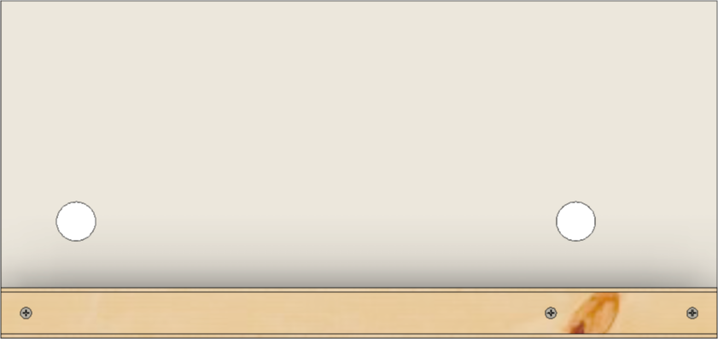

Align these sides

using 3 each particle board screws (#312).

Gluing to the base is a good idea.

The template bar should be aligned to the base as shown.

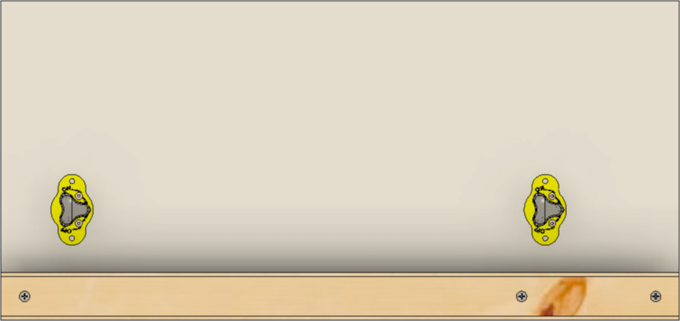Add the two MagSwitches (#206).

### Linear Slide

The linear slide is item #201 in the BOM. Some modifications are made to this, both shown in the revised diagram above. Firstly, there is a T-Track on the bottom edge of this. It can be used for limit switches, but I removed them to provide space for movement, though that may not be necessary.

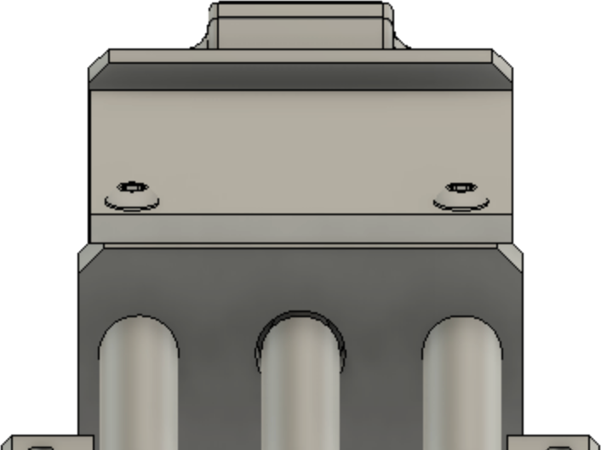Add a cover over the drive coupling. This is not critical but is in place to keep some dust out of the area.

Use ¼” aluminum plate. Cut the plate to match the opening. 85mm x 85mm is a good estimate for the size.

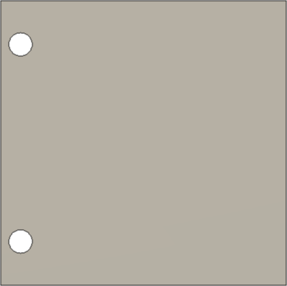

13 mm

13 mm

6 mm

85 mm

85 mm

Align the screws over the rods and be sure to not drill the holes too deeply. There should be no interference with the rods. This is shown in the picture to the left.

The holes in the plate are 7mm.

The two affixing screws will need holes drilled into the block below, and these holes tapped for the relevant holes. Screws like #313 are good. In this case, drill 5mm, and tap for M6-1.0.

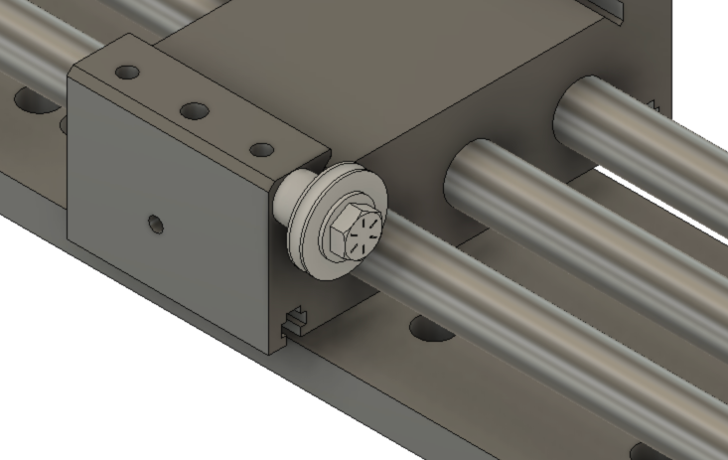Drill and tap a hole in the slide for the weight pulley. The screw is a ¼”-20, so drill #7 and tap.

The components attached to the slide are:

#306 – Screw

#308 – Pulley

#309 – Washer (2)

#310 – Spacer

The spacer is used to align this pulley with the two on the follower arm.

I recommend adding a label to this part at some place. On mine, it is in the area where the plate was added. The label should read as noted below.

Distance/360

0.19685” / 5mm

This information is needed when setting up the control system for this stepper motor. Having this information on a label on the device is useful in the case where you have other stepper-motor driven items.

Attach the linear slide

Align these sides

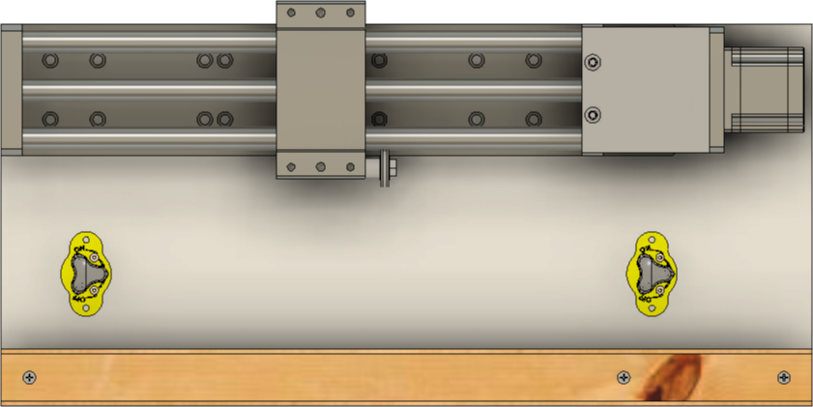

to the MDF base

using 6 or more particle board screws (#311). DO NOT use glue to attach these pieces together.

The linear slide should be aligned to the base as shown.

### Diagram, engineering drawing Description automatically generatedSlider Plate

The slider plate is affixed to the slide on the slide of the linear slide. This is shown in the picture to the right. (The screw holes in the sliders are not shown.)

The slider plate needs three holes drilled into it as shown in the picture below. These are centered in the trough.

The two larger holes are drilled for M8-1.25 screws (#314) but make them a bit larger than typically needed. This will allow for adjusting the alignment as needed. 11mm is recommended. Secure this in place using lock washers (#315).

The smaller hole is for an M4-0.7 screw (#316). It should be drilled 5mm. This screw is used to ensure the parts above this don’t slide off the back side. Thusly, the screw should be inserted from the bottom and held in place with an M4-0.7 nut (#317).

¼”

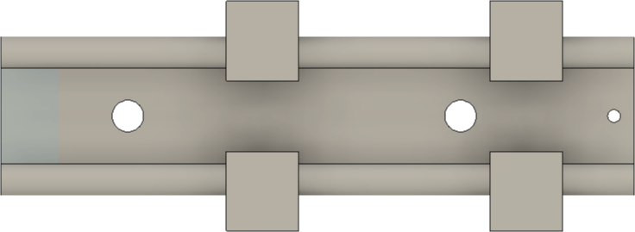

105mm

55mm

### Connector Plate

The connector plate attaches to the slider plate and provides the base for attaching several other pieces. It is made from ½” aluminum plate. It is shown below in orthogonal projection.

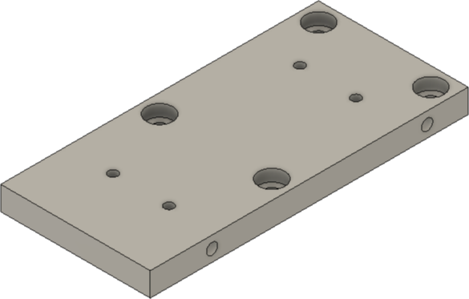

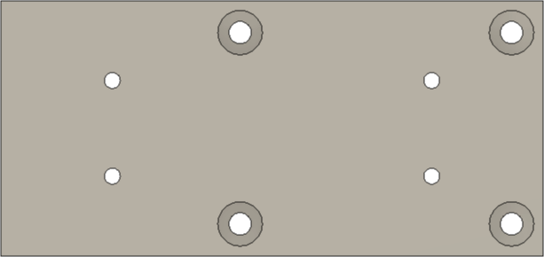

170 mm

75 mm

85 mm

100 mm

35 mm

10 mm

10 mm

80 mm

25 mm

30 mm



115 mm

33 mm

**Side View**

**Top View**

Drill 7 mm thru

Countersink 14mm dia, 1/4” deep

(typ)

Drill 5 mm thru

Tap 6M-1.0

(typ)

### Linear Stage Table

The purchased linear stage table (#202) is attached to the Connector Plate with 4 ea. Socket Head Screws, M6-1.0, 15mm long (#304).

It needs a few modifications before attaching it to the Connector Plate.

1. Drill and tap holes in the slide to attach the base for the Quick-Change Tool Post.
2. Drill and tap holes to the front to attach two plates for:
   1. Securing the rotation dial, and
   2. Indicating the rotational position of the rotation dial.

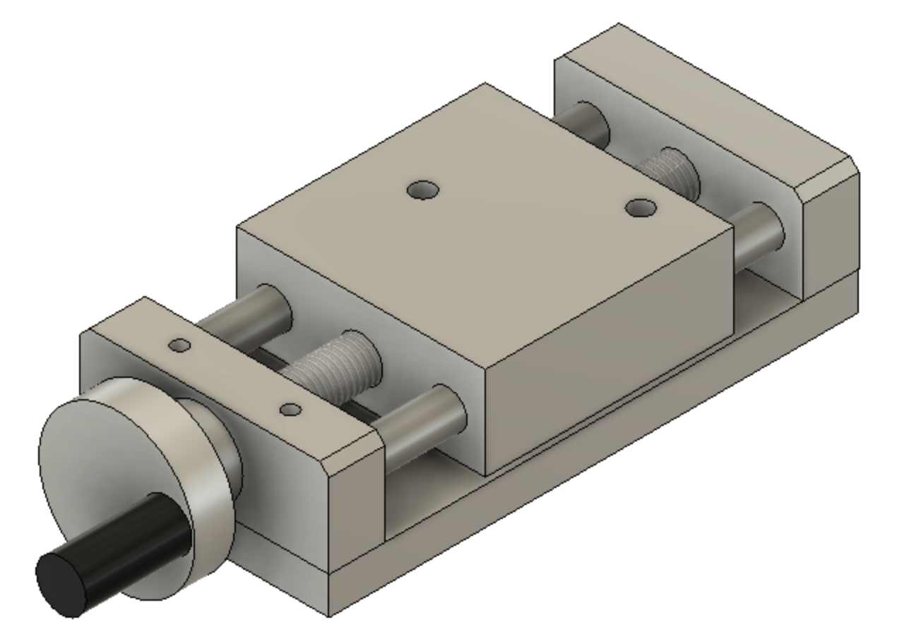

Those changes are shown in the picture to the left.

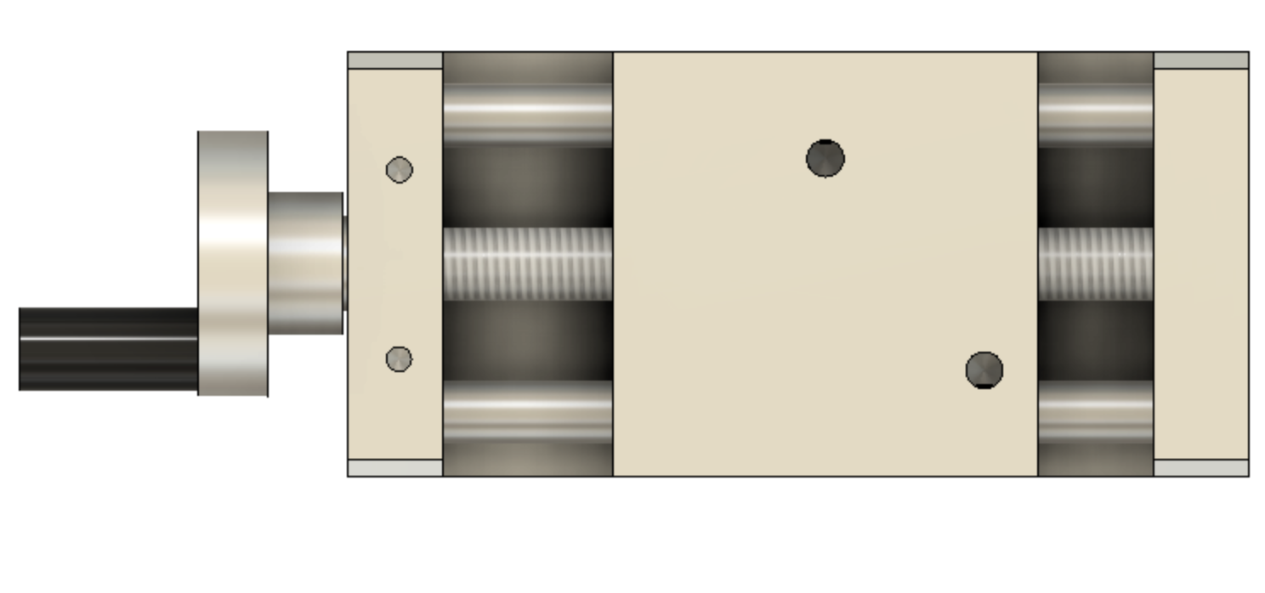

36 mm

22 mm

20 mm

40 mm

10 mm

40 mm

9 mm

Drill 5 mm 20mm deep

Tap 6M-1.0

(typ)

Drill 7 mm 20mm deep

Tap M8-1.25

(typ)

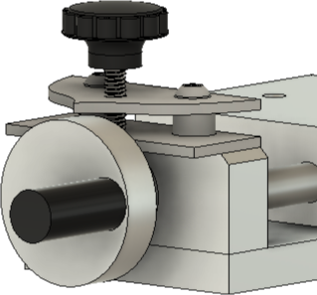The two plates used for the dial are shown to the left and shown installed in the picture below.

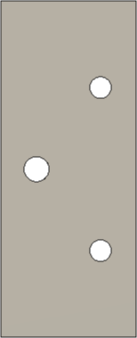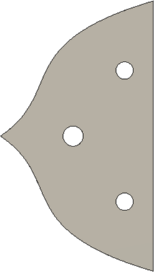

42 mm

9 mm

9 mm

21 mm

21 mm

30 mm

74 mm

37 mm

36 mm

19 mm

Drill #F thru

Tap ¼”-20

Drill 3/16” thru

Drill 3/16” thru

Drill 5/16” thru

**Dial Indicating Plate**

**Dial Locking Plate**

The two plates are attached to the linear stage table using M6-1.0 screws (#302). A spacer (#301) is between the Dial Locking Plate and the Dial Spacer Plate.

The locking knob is #303.

The dial should have indexing lines added. An example is shown below (all the lines are not shown). Placing them at the indicated spacing puts a line every 4.5º.

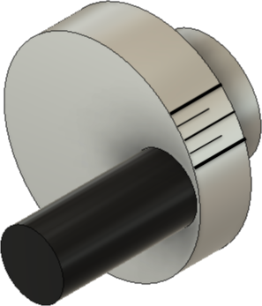

Thick lines, every 18º (20 lines around the dial)

Thinner lines, every 18º (20 lines around the dial). These are 9º separated from thick lines.

Thinnest lines, every 9º

(40 lines around the dial)

The result is that there are 80 indicating lines around the dial. The screw used to move the slide is M14-2.0, so each indicating line moves the slide by 0.025mm, which is close to 0.001”.

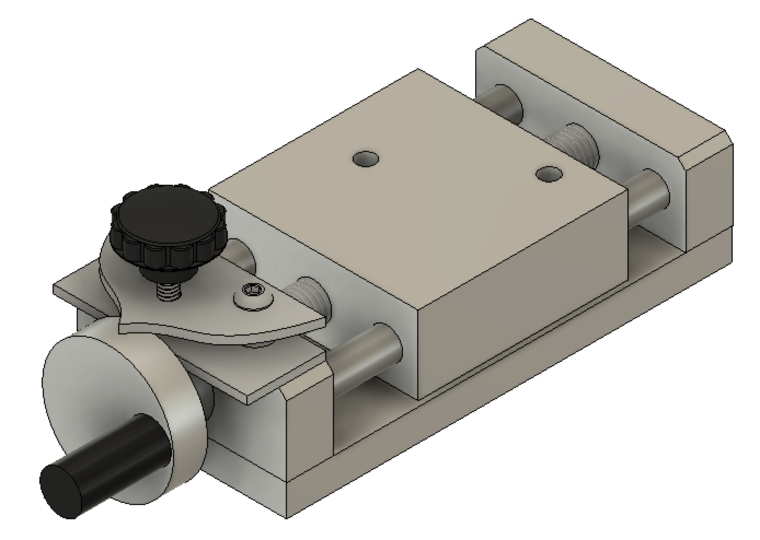

0.0787” / rev

2mm / rev

Into Piece

Out from Piece

0.001”

0.025mm

Finally, add labels. The one denoting which way to turn the dial to move the cutter into or out from the piece is particularly useful. This is because the screw is not reverse threads, so it turns counter-intuitively.

### Follower Arms

The Follower Arms are used to move the cutter in the path outlined by the template. It also provides pulleys for the weight cable.

These arms are attached to the Connector Plate with 4 ea. Socket Head Screws, M6-1.0, 15mm long (#304).

The pieces are detailed below.

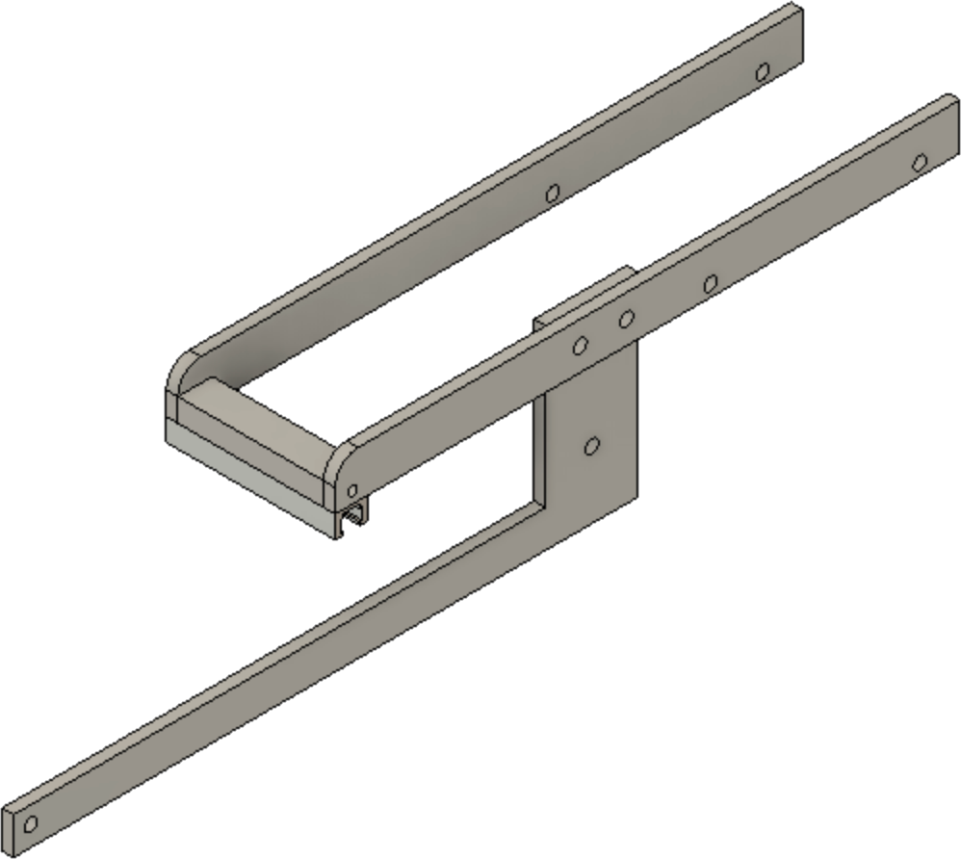

**Left Arm**

**Right Arm**

**Weight Arm**

**Follower T-Track Plate**

**Follower**

**T-Track**

The key parts are shown in the diagram to the right.

The Follower T-Track needs to be cut 92mm long.

These two parts are made from 1” x ¼” aluminum rod.

Drill #H thru



22 mm

115 mm

13 ½”

7 ¼”

1”

3/8”

¼”

1”

½”

¼”

**Left Arm**

**Right Arm**

Drill 7mm thru

Drill 7mm thru

Drill 7mm thru

These Follower T-Track Plate is made from ¾” x ½” aluminum rod.

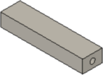

**Follower T-Track Plate**



80mm

Drill 5 mm 20mm deep

Tap 6M-1.0

(both ends)

**Orthogonal View**

**Side View**

**End View**

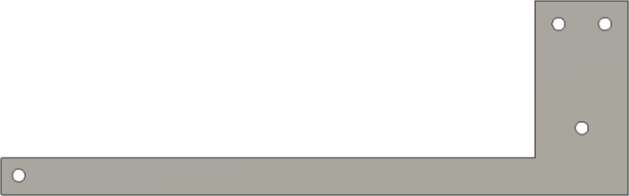

Drill #H thru

(typ)

10”

1 1/8”

2”

½”

½”

4 ¼”

1”

3/8”

3/8”

¾”

**Weight Arm**

The Weight Arm is made from ¼” aluminum plate.

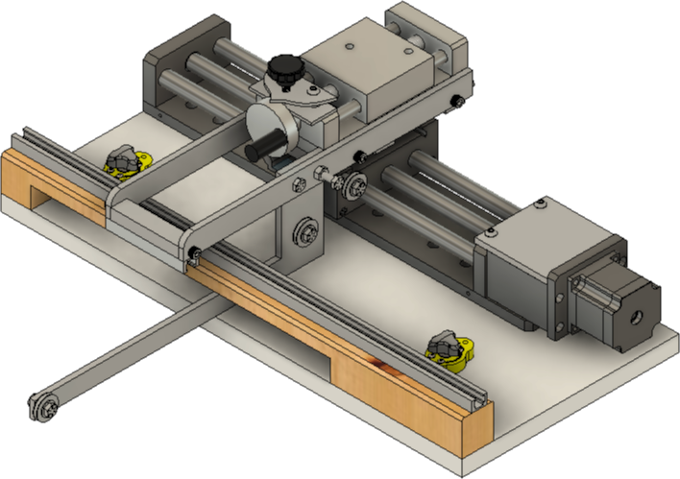

Socket Head Screws, M6-1.0 (#304)

(both sides)

Screw, ¼”-20 (#305) & Nut (#307)

Screw, ¼”-20 (#305) & 2 Nuts (#307)

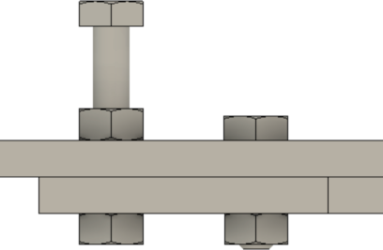

Screw, ¼”-20 (#305), Nut (#307), 2 Washers (#309), & Pulley (#308)

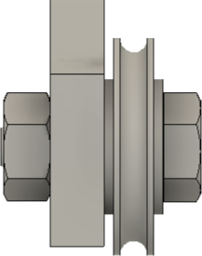

### Quick-Change Tool Post

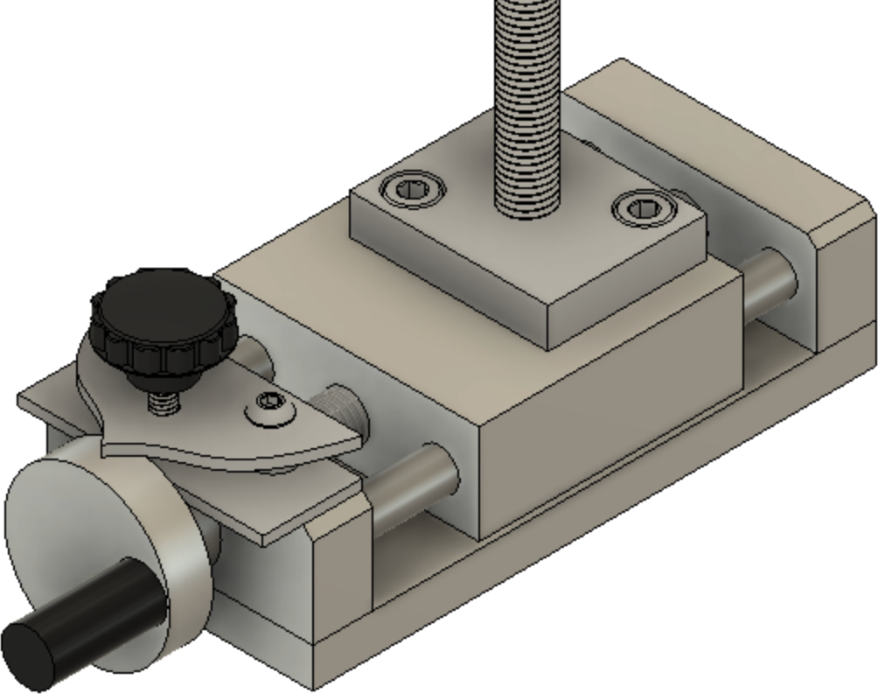

M8-1.25 Screws

The quick-change tool post is attached to the top of the Linear Stage Table using M8-1.25 screws.

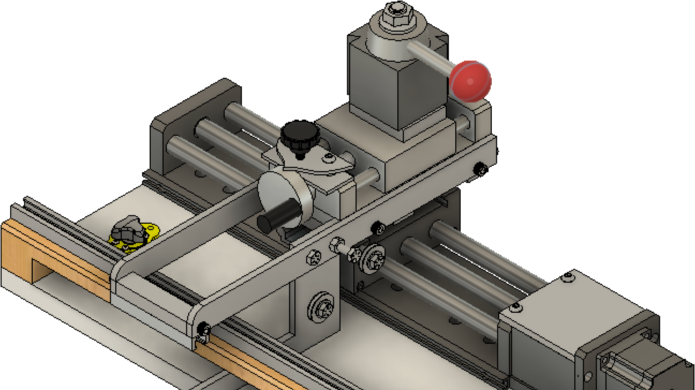Once the rest of the QCTP parts are installed, it will look like the picture below.

### Weight & Cable

The cable for the weight is installed along the path shown in red below.

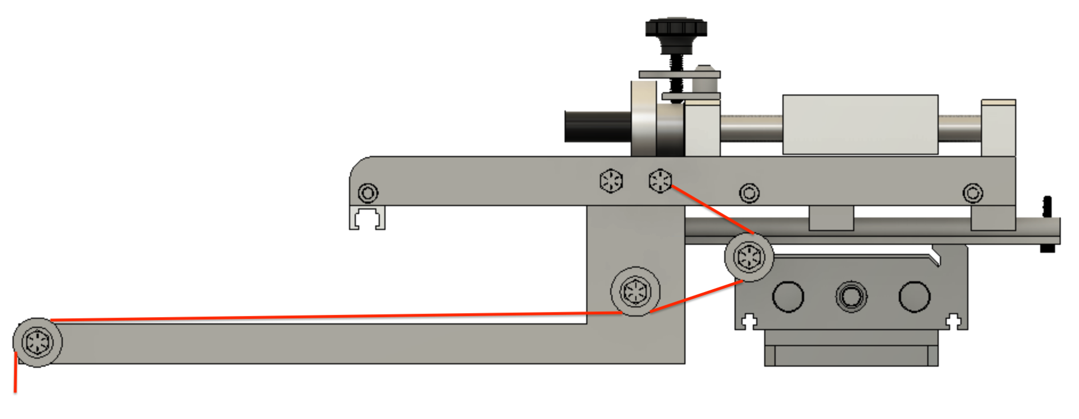

Wrapped around this bolt

Goes down to the weight

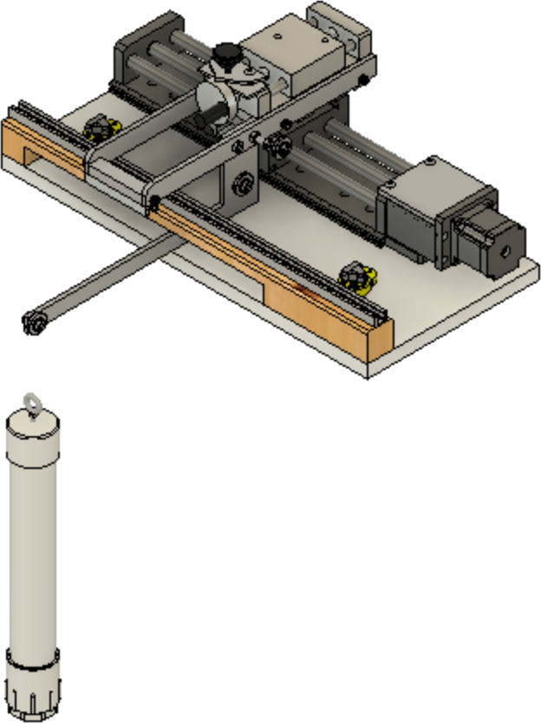When the weight is attached to the weight arm, it will hang down like the picture to the right.

The weight can be made from many things. What is proposed is to use 1 ½” PVC Pipe, Schedule 40. The one shown has a cap on the top, and a screw-in fitting on the bottom.

The top has an eyebolt in it. A ¼”-20 eyebolt is sufficient. Fill the tube with something to give it a total weight of 5 lbs. You may need to adjust that weight to have it work as expected. When the weight is correct, the slide will be pulled towards the back of the rose engine, keeping it engaged with the template.